Four Sided Christmas Ball Ornament
This four sided Christmas ball ornament is an easy paper craft to hang on the Christmas tree this year. Let your little ones get creative with this easy kids Christmas craft.
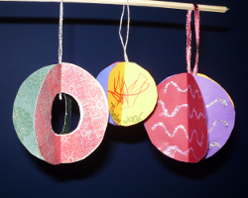
Materials:
- Scrapbook paper
- Glue stick
- Ribbon
- Glitter Glue
- Glitter Pens or Markers
- Paperclips
Steps:
- Cut four circles of the same size from the scrap book paper.
- Add additional decoration as desired on each circle using glitter glue or glitter pens. Let dry.
- Fold each circle in half.
- Cut about a 6” piece of ribbon
- Using a glue stick, glue along one half of one circle. Fold cut ribbon in half and glue on the folded edge of the circle.
- Place one half of another circle on the glued side of the other matching curved edges. Use a paperclip to hold in place until the glue has dried. Repeat for each circle, gluing the forth circle to the first.
- Optional: You may cut out an additional shape from the middle of each circle for added effect. (see picture)

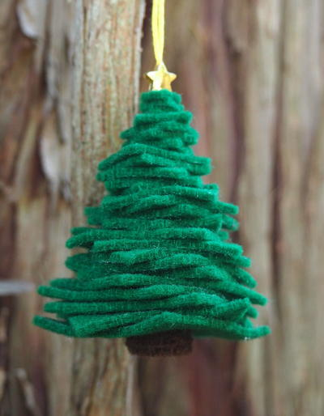

Little Hands Christmas Tree Crafts
"This adorable felt Christmas tree ornament will look so festive up on your tree. And it's easy to make with just pieces of felt so kids can help make their own!"
Estimated Cost: Under $10
Time to complete: Under an hour
Primary Technique: Sewing
image: http://static.primecp.com/images/kidfriendly_14.png

Materials List
- Felt
- Needle
- Embroidery thread
- Star bead

Instructions
- From green felt, cut out five 1 squares, five 1 squares, five 1 squares, five squares, five squares, and five squares. From brown felt, cut out five circles about in diameter. Thread the needle with embroidery floss, bring the ends of the floss together and tie in a knot.
- Poke the needle through the center of each circle and thread them onto the floss.
- Poke the needle through the centre of the 1 squares and thread them onto the floss. Continue to thread squares onto the floss from largest to smallest in size.
- Lastly, thread on the star bead. Cut off the needle and tie the two loose strands of floss together with a knot.

Notes
TIP: If you are making this with younger children you might want to pre-poke a hole in the center of each felt piece to make it easier for them to thread.

Tiered Christmas Tree Ornament
By: Mandy Court for MaKC Creations
Get out the scrapbook paper and create fun and easy Christmas tree ornaments with your kids.
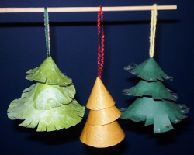
Materials:
- Scrapbook paper
- Glue stick
- Pony beads
- Ribbon
- Glitter Glue
- Glitter Pens or Markers
- Paperclips
Steps:
Cut three circles (small, medium, large) from your scrap book paper.
- Cut out of each circle the quarter section as marked
- Add additional decoration as desired on each circle using glitter glue or glitter pens. Let dry.
- Using the glue stick, glue along on straight edge.
- Pull the other straight edge to over lap the glue making a cone. Place a paperclip along the glued edge to hold in place until the glue dries.
- Cut a piece of ribbon about 10” long. Fold in half. Tie a pony bead on to the loose end (the pony bead is to keep the cones from sliding off the ribbon or out of place). Thread the ribbon through the hole in the top of the largest cone (if the hole is too small make a small cut so the ribbon will thread through.
- Tie another pony bead about 1” above the large cone. Thread the ribbon through the whole of the medium cone.
- Tie another pony bead on about 1” above the medium cone and thread on the smallest cone.
- Optional. Cut slits in the lower edge of each cone and curl the slitted paper upwards using a pencil.

Easy Icicle Ornaments for Kids
By: Mandy Court for MaKC Creations
These easy beaded icicle ornaments are a fun and easy craft for the kids to do this Christmas. Use colorful sequins and metallic beads to make these easy Christmas ornaments.
image: http://static.primecp.com/master_images/Christmas-Crafts/metallic-beaded-icicles.JPG
Materials:
- Metallic, crystal or opaque beads in assorted shapes and sizes
- Metallic pipe cleaners
- Large sequins of any shape (Stars in Picture)
Steps:
- Thread one large sequin on to the pipe cleaner. Fold up about 1/4” of the pipe cleaner to make a knot (so the sequin does not slide off).
- Thread on beads in desired pattern until you reach your desired length. Be sure to leave about 3” of pipe cleaner at the top to make a loop.
- Bend pipe cleaner over to just reach the last bead. Twist the end to hold in place. Now you should have a loop to hang your icicle on the tree.

